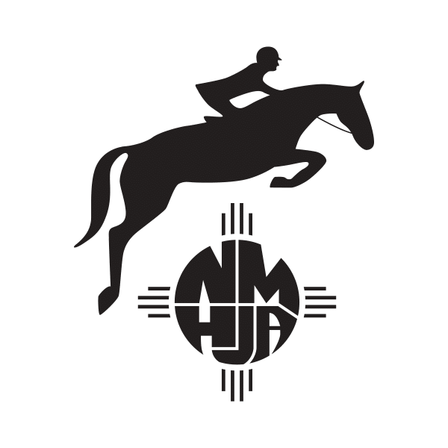
New Mexico Hunter-Jumper Association
P.O. Box 10357
Albuquerque, NM 87184
505-350-4390 beckynewmon@yahoo.com

2023 Application for Membership
The NMHJA membership year begins on December 1, 2022. All current memberships expire on November 30, 2022. The effective date of membership is the date the application and payment are received by NMHJA. Any points won by you or your NMHJA recorded horse prior to the effective date of your membership will not be considered.

Renewal: ☐ NMHJA New Membership: ☐

Name:______________________________________________________________

Address:_____________________________________________________________________

Telephone: Day: _________________Evening: ________________ Date of Birth:___________

Email Address: _________________________________USEF # _________________________

Category of Membership Desired: (Check One. Fee Must Accompany Application)
☐ Adult: $50.00 - Please check age group as of 12/1/21: 18-35 ☐ 36 & O ☐
☐ Junior: $50.00- Please check age group as of 12/1/21: 11 & U ☐ 12 - 14 ☐ 15 -17 ☐
☐ Professional: - $50.00
☐ Farm/LLC: - $50.00
Horse/Pony Registration- $30.00/horse:
List names and sizes of horses/ponies you own and wish to register with NMHJA. Both riders and owners (lessees) must be registered for points to count. Use the same name for the entire year.

Name: _________________________Height: __________ USEF #__________NMHJA # ______New: ☐

Name: _________________________Height: __________ USEF #__________NMHJA #______ New: ☐

Name: _________________________Height: ___________ USEF#_________NMHJA # ______ New: ☐

**can mail a check or Venmo @Becky-Newmon for payment. If Venmo, please email membership application to beckynewmon@yahoo.com
For NMHJA Use Only
Check # _______________
Date: _______________
Member #______________

Membership Fee: ________________
Horse/Pony Registration(s): ________________
Total Amount: ________________

